ARCHITECTURE

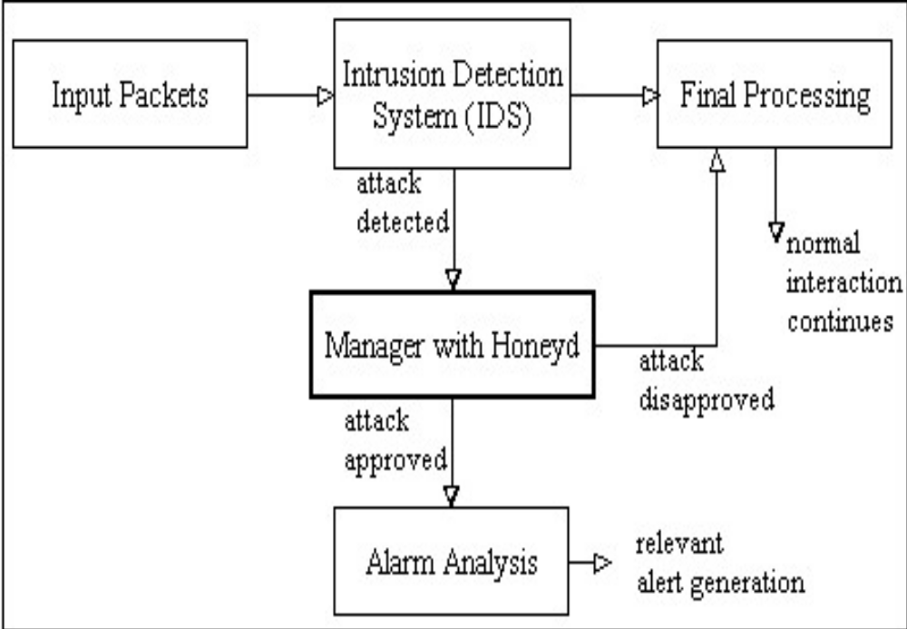

Module Explanation

Director
Director acts as a commander in this system. Once an external agent reports an attack to the manager, the director compares the situation with the ”Agent Risk Threshold”. Risk threshold is the boundary which is used to warn an attack if interaction exceeds the limit of the specific agent. The director refers to the records to check the threshold assigned to each agent. If the risk of the attack exceeds the threshold, the director engages the manager parts, mainly honey pot, to deal with the connection. Therefore all the important attacks are lead to honey-pot for a more close investigation.

Intrusion Detection System
Intrusion detection technology in general helps to find out the illegal intrusions from inside and outside of the local network by tracking the intruders’ trail, such as the records of failure access trails. A typical IDS consists of the following parts: event generator, event analyzer, response units and event databases. The data are exchanged in form of GIDOs (Generalized Intrusion Detection Objects) between the parts. GIDO is the specification of messaging as its encoded content is either some particular occurrence happened at some particular time, or some conclusion about a set of events or an intrusion to carry out an action. Each part might be implemented as a single process on a computer, or might be a collection of many processes on a number of computers. The event generator obtains events from data outside the intrusion detection system, generates events based on the traffic thereon and handovers them in GIDO format to the other parts.

Records
The records provide a database including a crime table, policy table, reports and event logs. The director for making decisions refers to this database and also enters new rules and signatures derived from new attack. Director constantly modifies the signature list that are used by external agents. Records part is equipped with a system which organizes the signatures coming through the database and enables the director to get access to the current signatures and update them or insert new ones.
Honeypot
Using the honeypot scheme, this system is able to avoid many wrong decisions made by IDS. In this system alarming adversaries, initially detected by the IDS, will be rerouted to a honeypot network for a more close investigation. If as a result of this investigation, it is found that the alarm decision made by the IDS of the agent is wrong, the connection will be guided to the original destination in order to continue the previous interaction. This action is hidden to the user.

